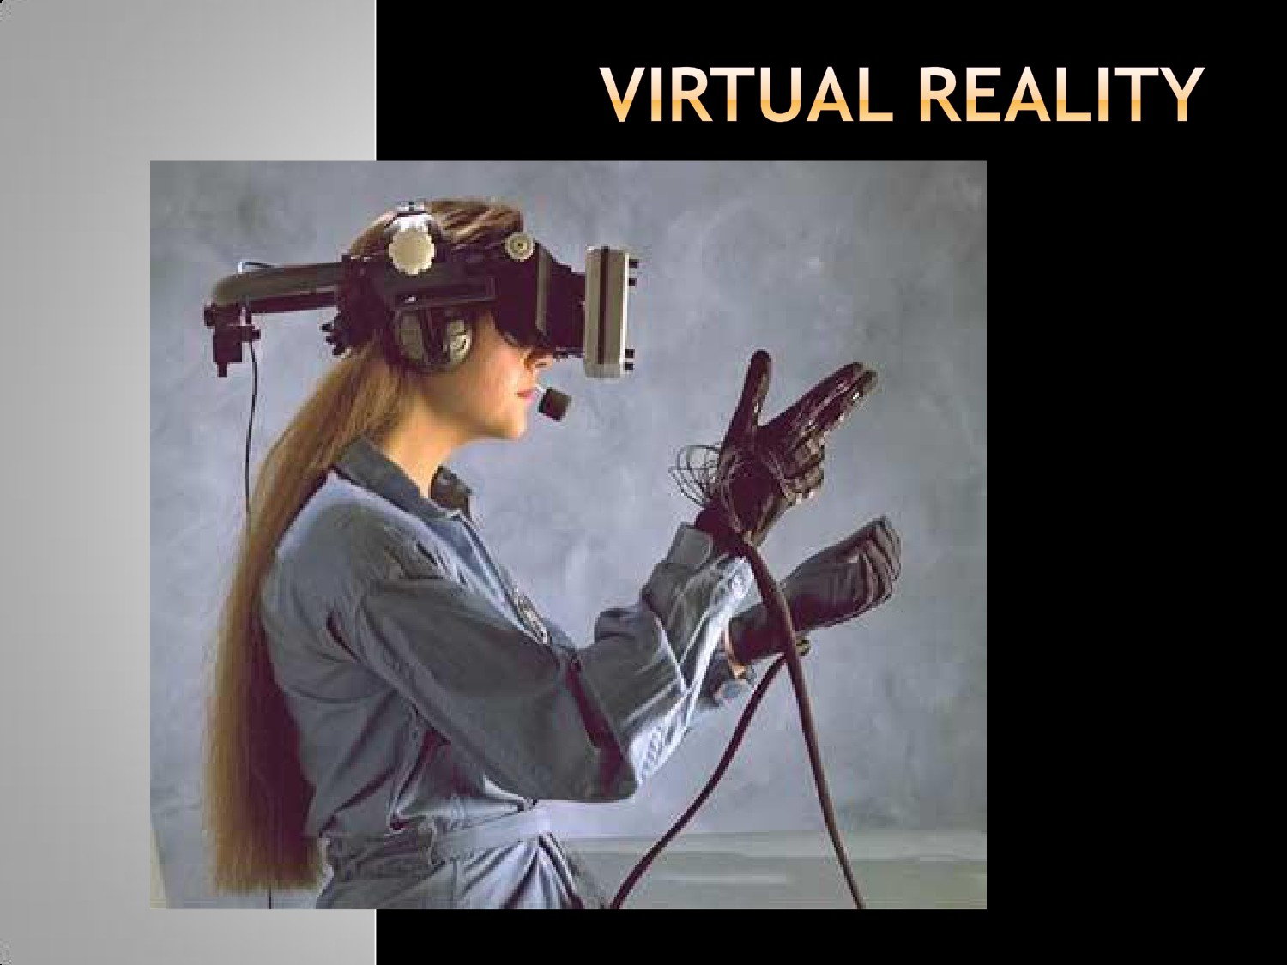

What VR is not:

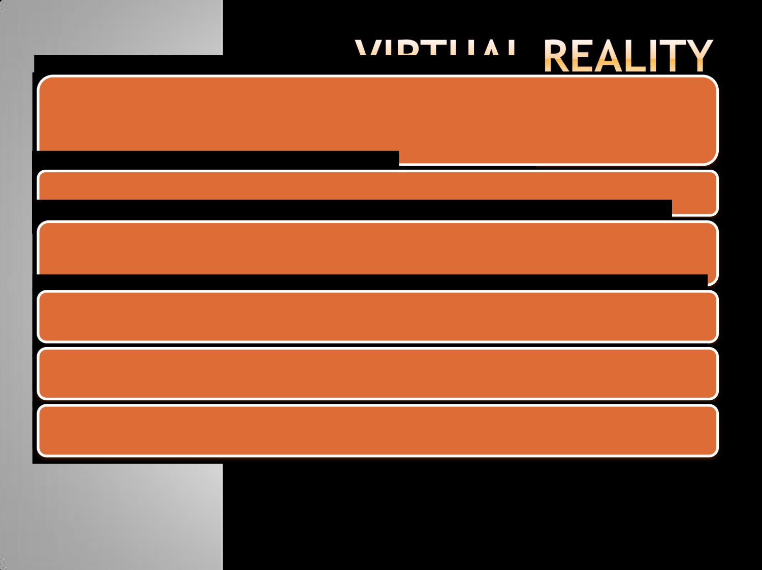

- VR is not just any form of Computer Graphics

What VR is:

- “A system for providing an interactive exploration of a three

dimensional virtual environment”

“The use of 3D graphics displays to explore a computer generated world”

- An attempt to model the real world as believably as possible

- An advanced form of human computer interface

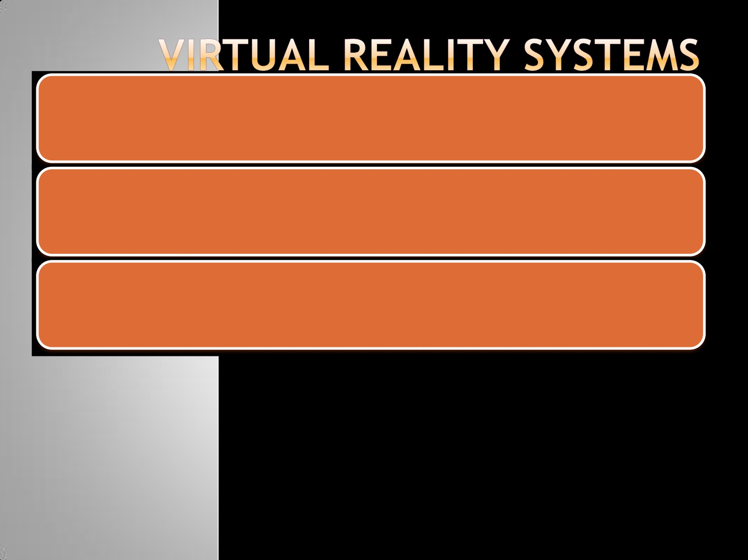

A typical VR system consists of six main components grouped into two:

a. Internal Components:

i. Virtual world ii. Graphics Engine

iii. Simulation Engine iv. User interface

b. External Components:

i. User inputs ii. User outputs

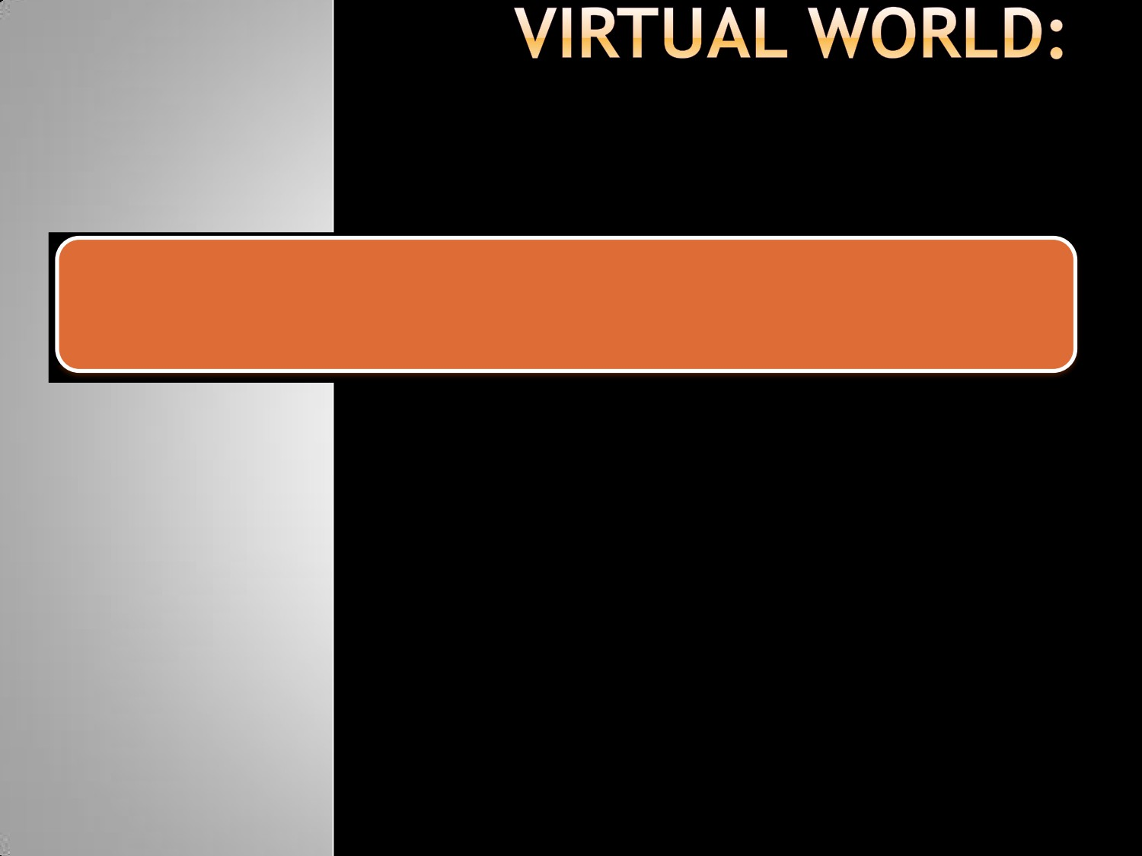

A scene database containing the geometric representations and attributes for all objects within the environment

Responsible for actually generating the image or scene, which a viewer will   
see



Usually the scene database and the viewer’s current position and orientation is taken into account

It also includes other information form the scene data base e.g. sounds, special effects textures etc

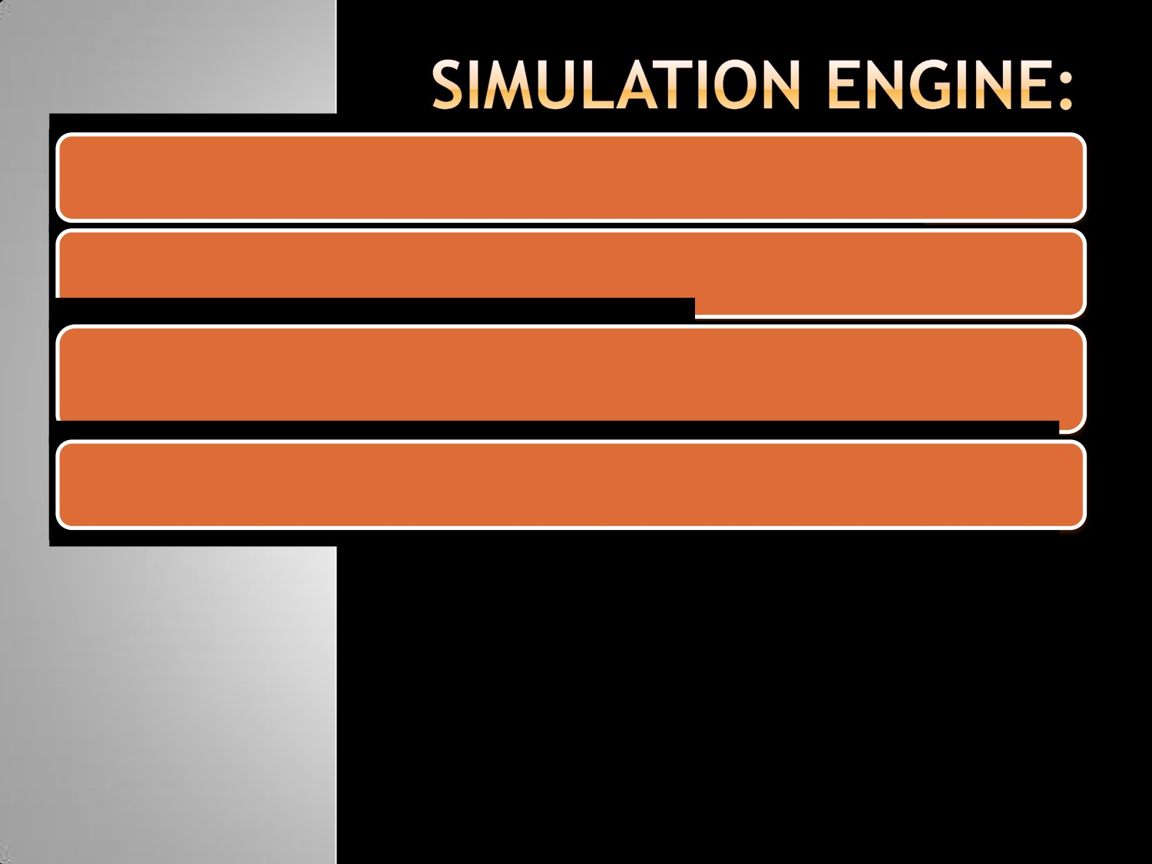

Does most of the wok required to maintain virtual environment

Concerned purely with the dynamics of the environment

- how it changes over time

- how it responds to the user’s actions

This includes handling interactions, physical simulations (gravity, inertia)

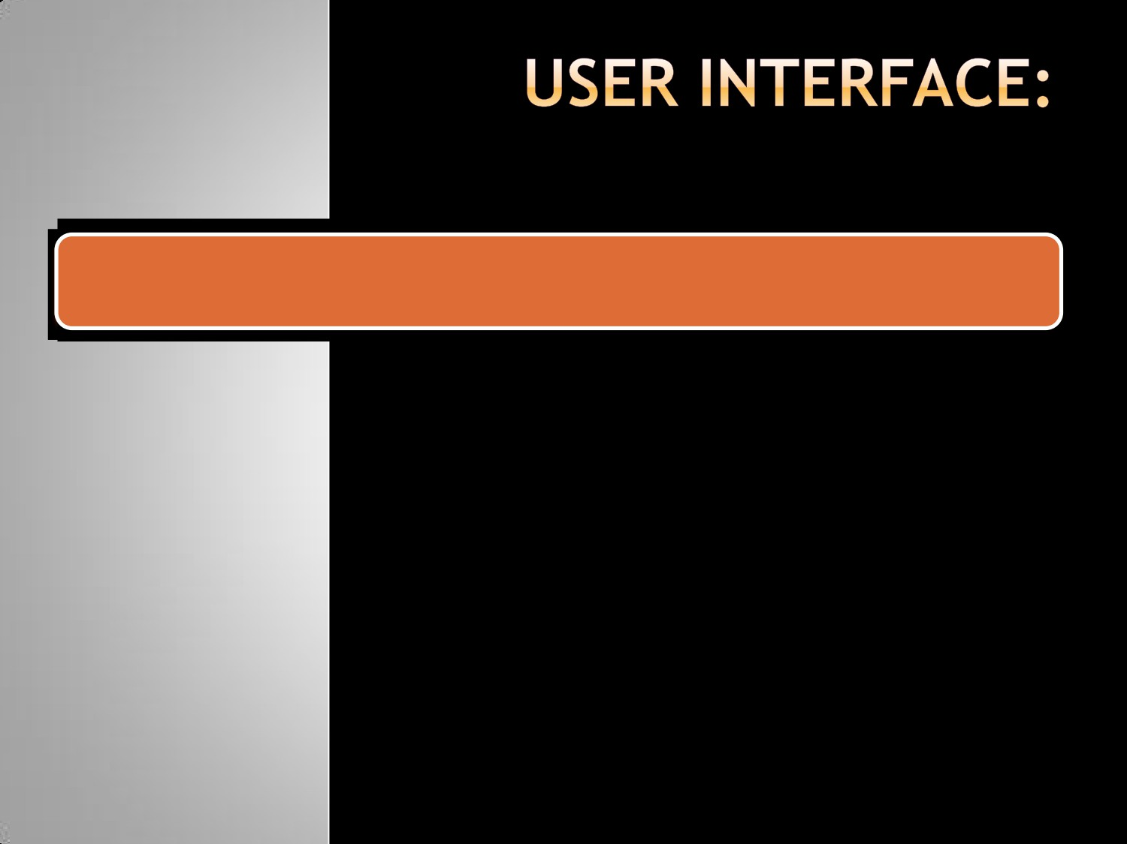

Controls how the user navigates and interacts with this virtual environment

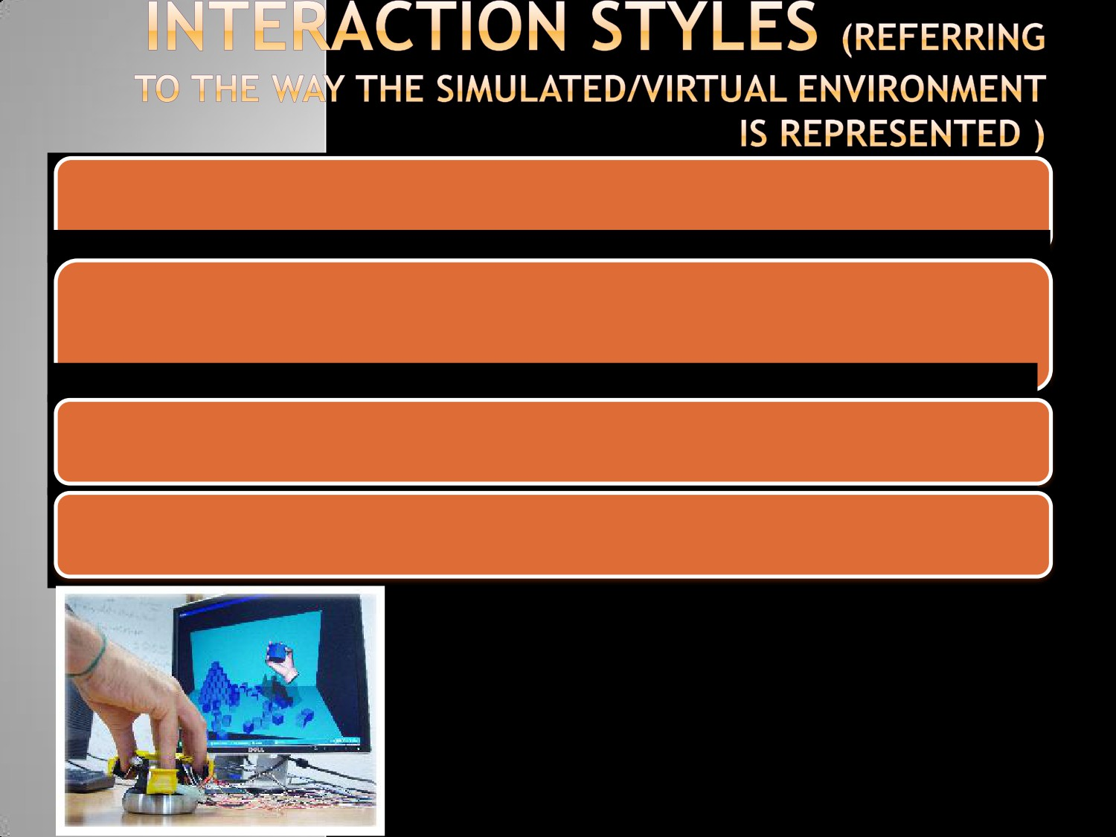

i. Desktop VR

- Based on the concept that the potential user interacts with the

computer screen with out being fully immersed and surrounded by the computer generated environment

- Applications domains involve architecture, industrial design, data

visualization

- Less cost and involves less use of interacting technology

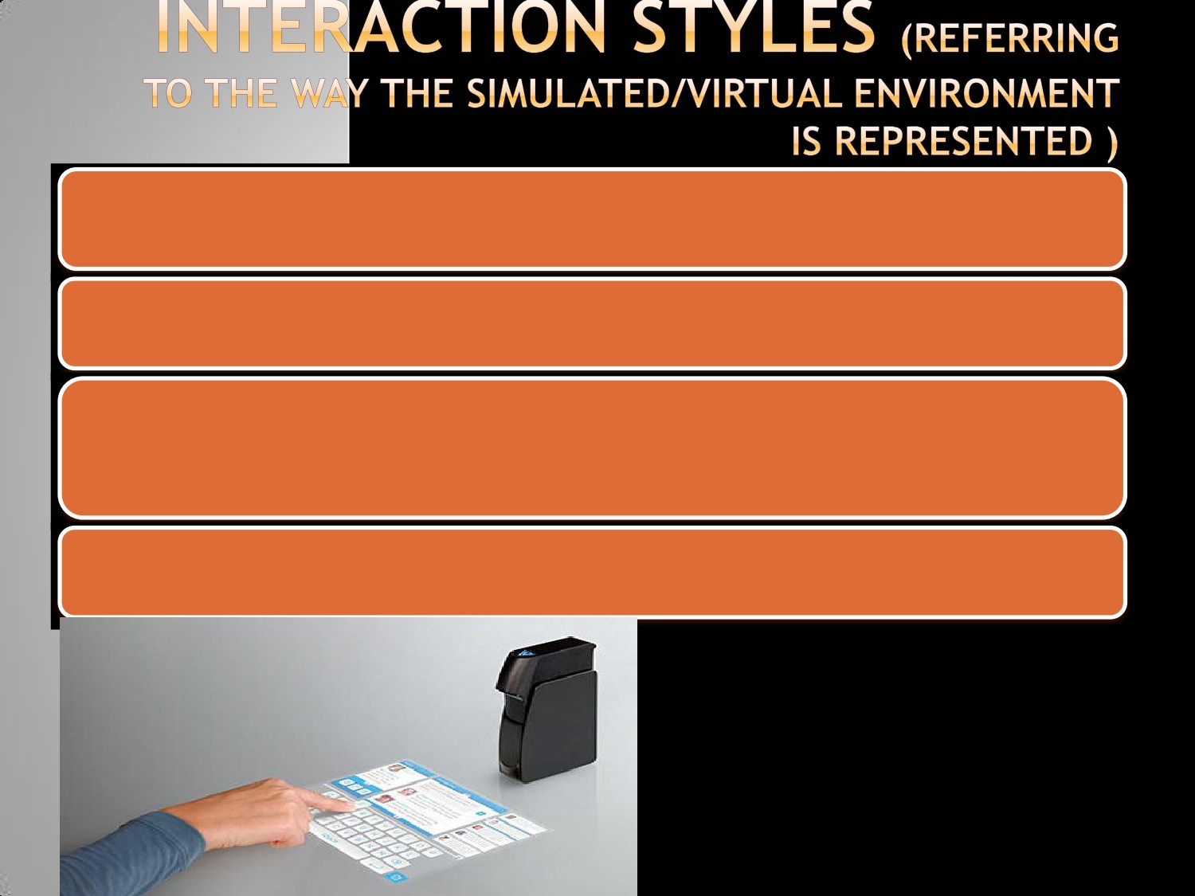

ii. Projected VR

- Based on overlapping of the image of the real user on the

computer generated world

- A special movement tracking device can capture the movements of

the user and enter them so that they can cause actions and reactions in the virtual world

- Often used in VR Art shows

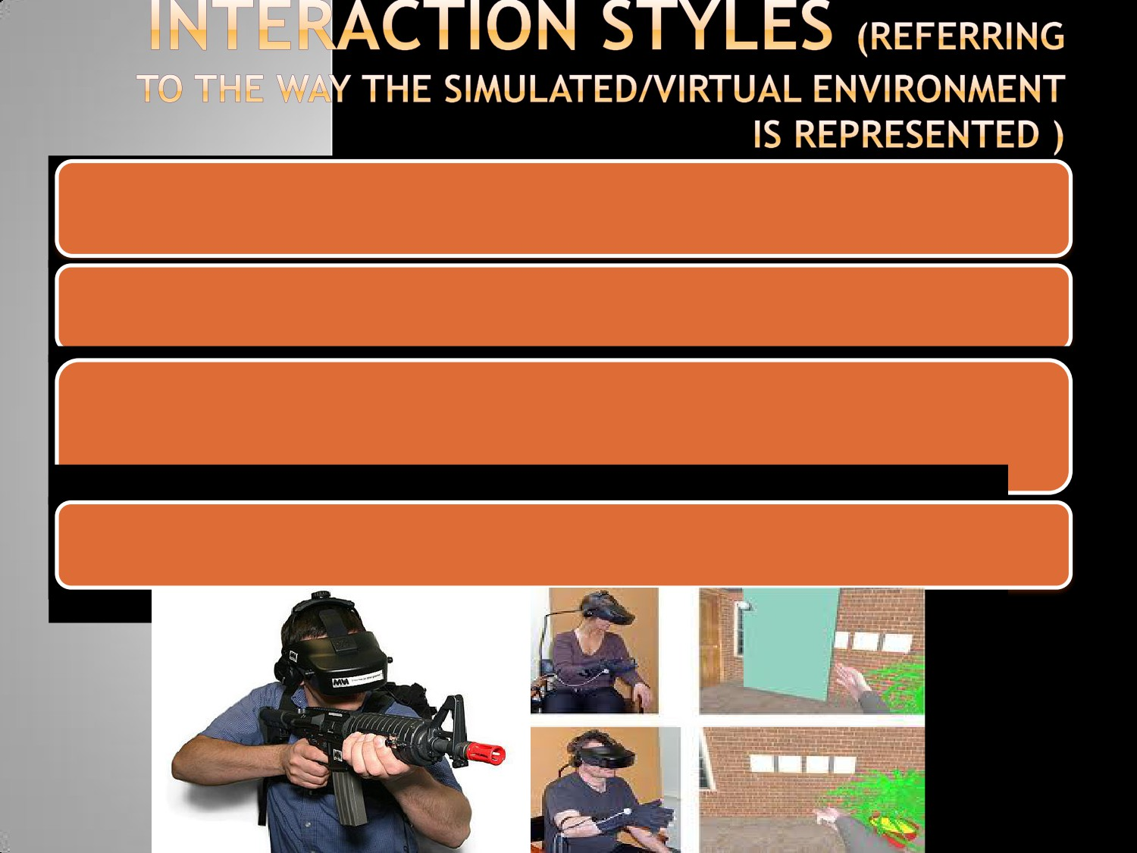

iii. Immersive VR

- The user appears to be fully inserted in the computer generated

environment

- Illusion rendered by providing HMD (Head Mounted Device) with 3D

viewing and a system of head tracking that gives the exact

correspondence and coordination of the user’s movements with

the feed-back of the environment

- The goal is to completely immerse the user within a synthetic

environment or make them feel a part of that environment

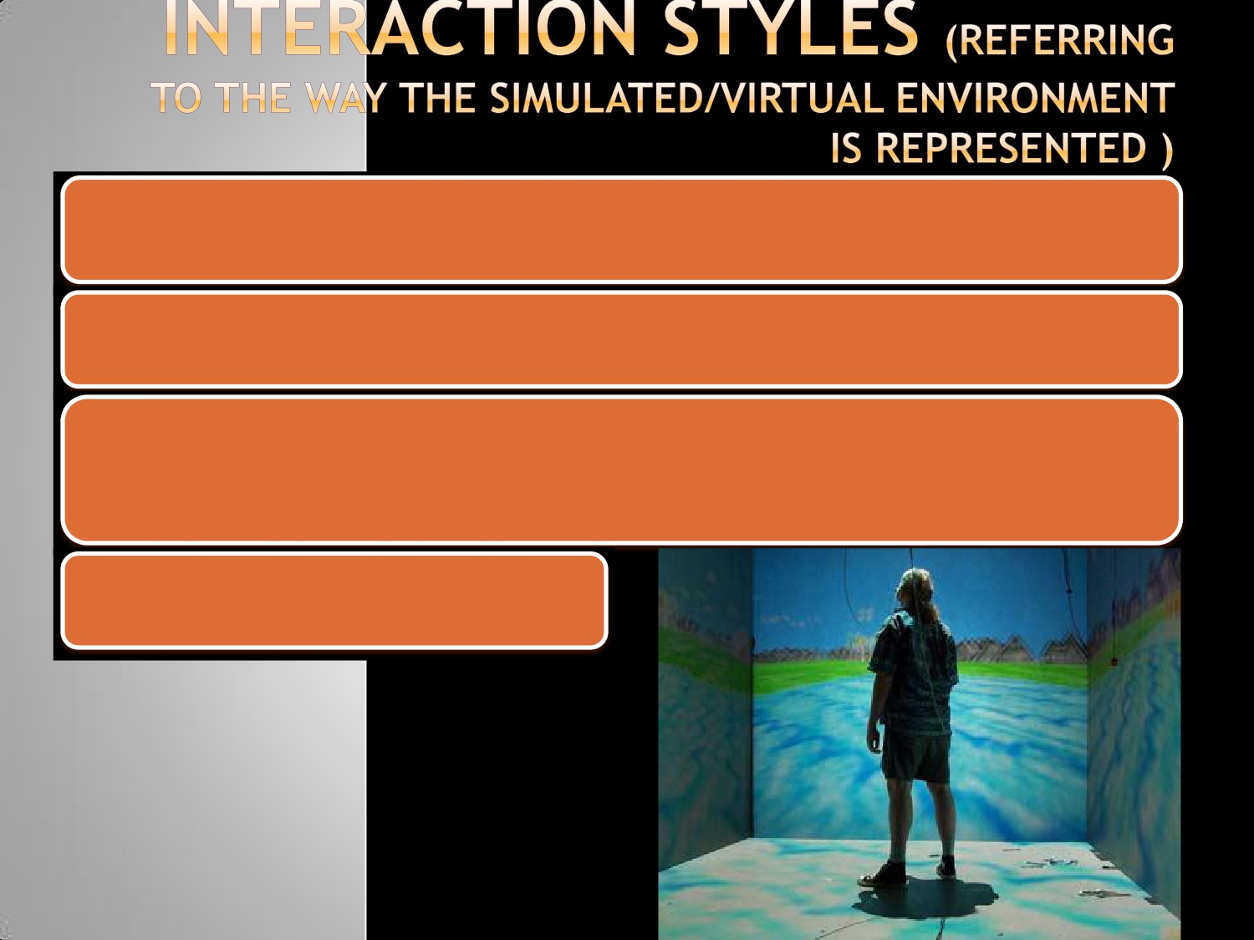

iv. CAVE or Fish Tank VR

- Cave is a small room where computer generated world is projected

on the front and side wallsusing projectors

- Suitable for collective VR experience (allows different people to

share the same experience at the same time)

- e.g. cockpit simulations

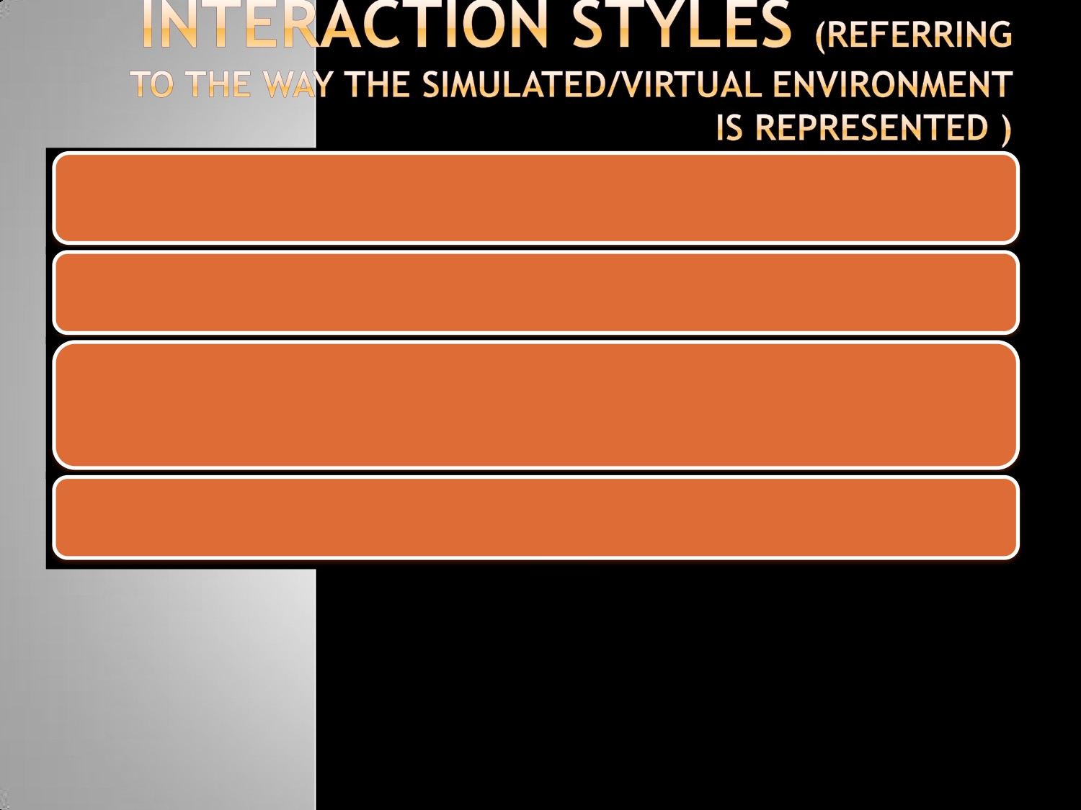

v. Tele-presence

Here, users can influence and operate in a world that is real but in a

different location

Telepresence is used for remote surgical operations and for exploration and manipulation of hazardous environments (space, underwater)

Remote robots used in bomb disposal operations

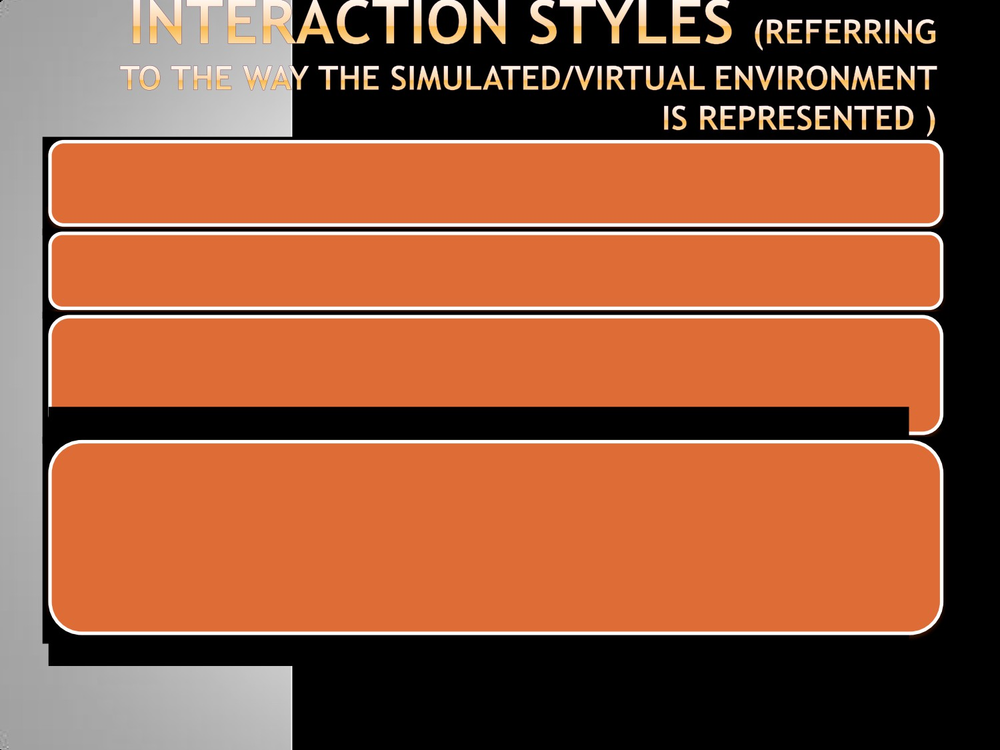

vi. Augmentation

- mixed reality provides a half way point between an non immersive

and fully immersive VR system

- a user’s view of the world is supplemented with virtual objects and

items whose meaning is aimed at enriching the information content of the real environment

e.g. Head Up Displays (HUD)

- Used in modern military aircraft

- These superimpose flight data such as altitude, air speed upon

the pilots field of view

- This can be on a cockpit mounted display or upon the pilot’s

helmet visor

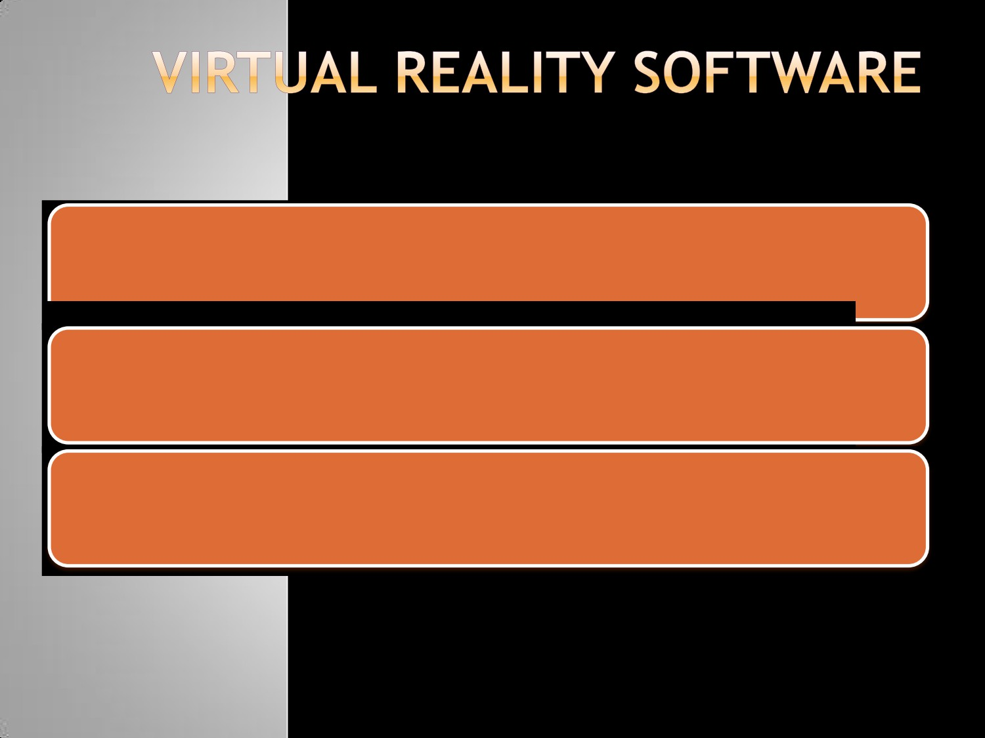

Software packages exist that allows users to either experience virtual worlds or even create and edit them

3D graphics engines and immersive environments has occurred in the gaming industry

Most VR Packages are costly and require high specification workstations to run properly

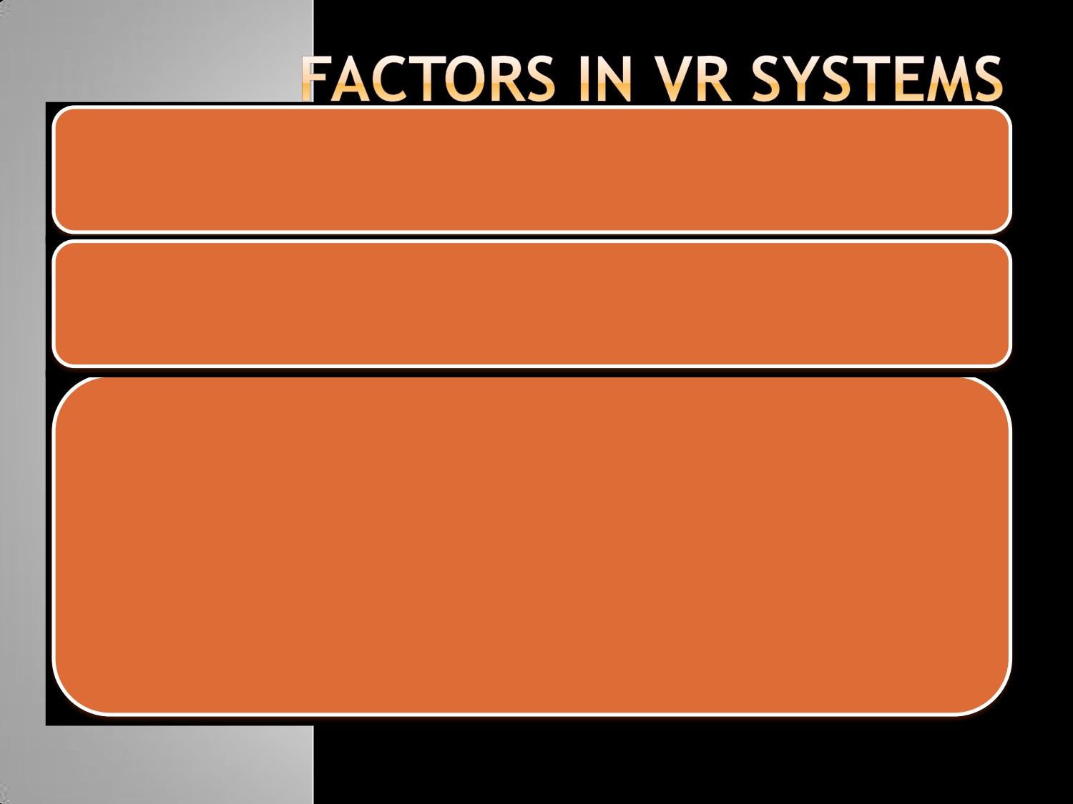

Factors that can attribute to a realistic and believable virtual environment:

Visual realism:

- The level of realism in a scene helps considerably in making a

believable environment

- With best applications, the viewer does not notice any transition

between real footage and computer generated effects

- But it requires a lot of rendering time

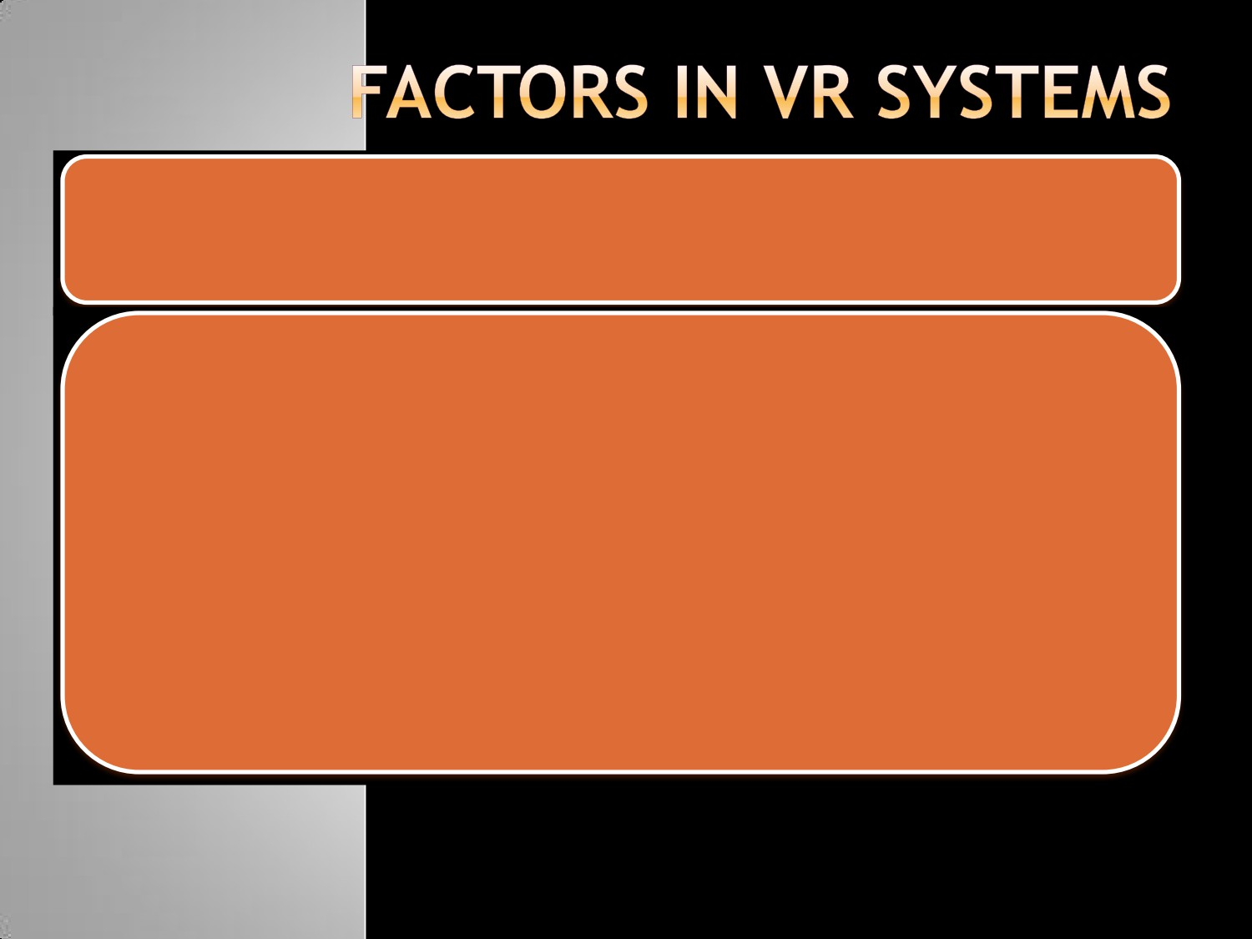

Image Resolution

- Image resolution is closely linked with visual realism

- Computer generated images contain pixels , the size and number

of these are dependent on the display size and resolution

- The color and intensity at each pixel must be generated

individually, putting a heavier load on the graphics system

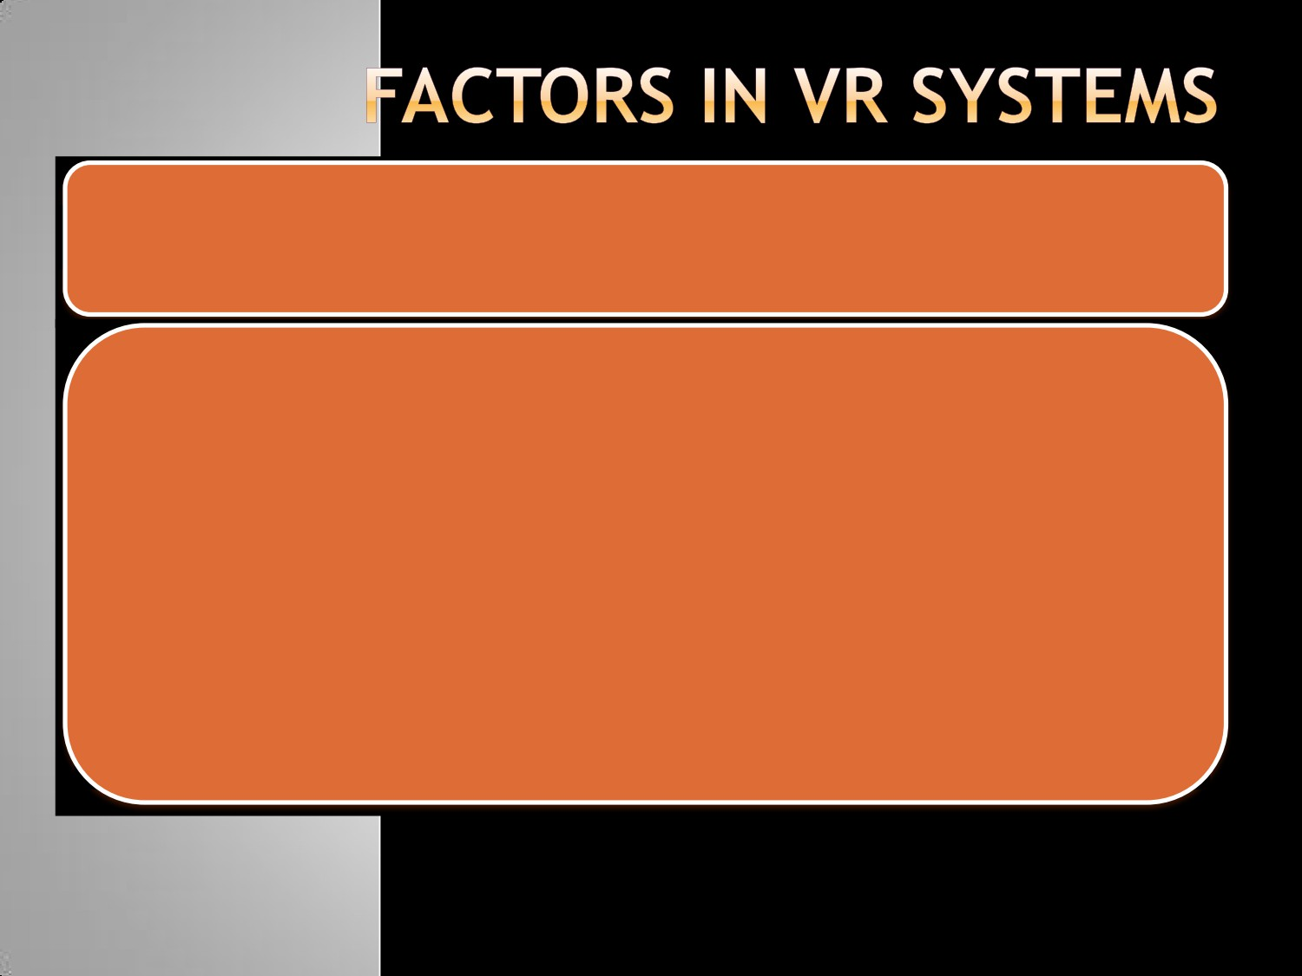

Frame Rate

- To give the impression of a dynamic picture, the system updates

the display very frequently with a new image

- Images stop flickering at frequencies above CFF which can be as

low as 20 Hz

- Normal TV broadcasts update at a frequency of 50 Hz in the UK

, 60 in the US

- Achieving this refresh rate puts a heavy load on the graphics

system

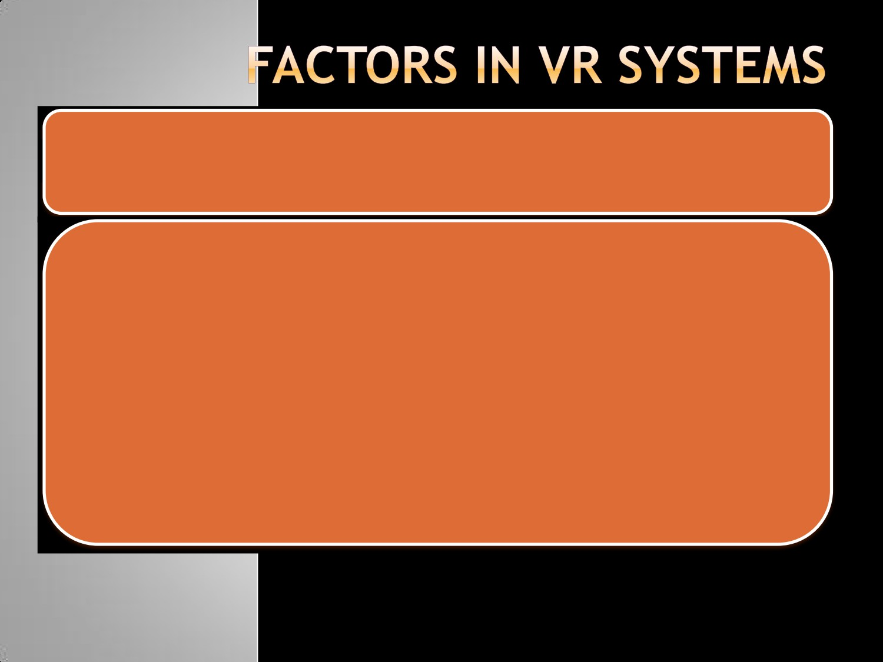

Latency

- Latency or lag is the delay induced by the various components

of a VR system between the user’s inputs and the

corresponding response from the system in the form of a change in the display

- As latency increases a user’s senses become increasingly

confused as their actions become more and more delayed

- Chronic cases can result in simulator sickness, hence latency

must be kept to a minimum

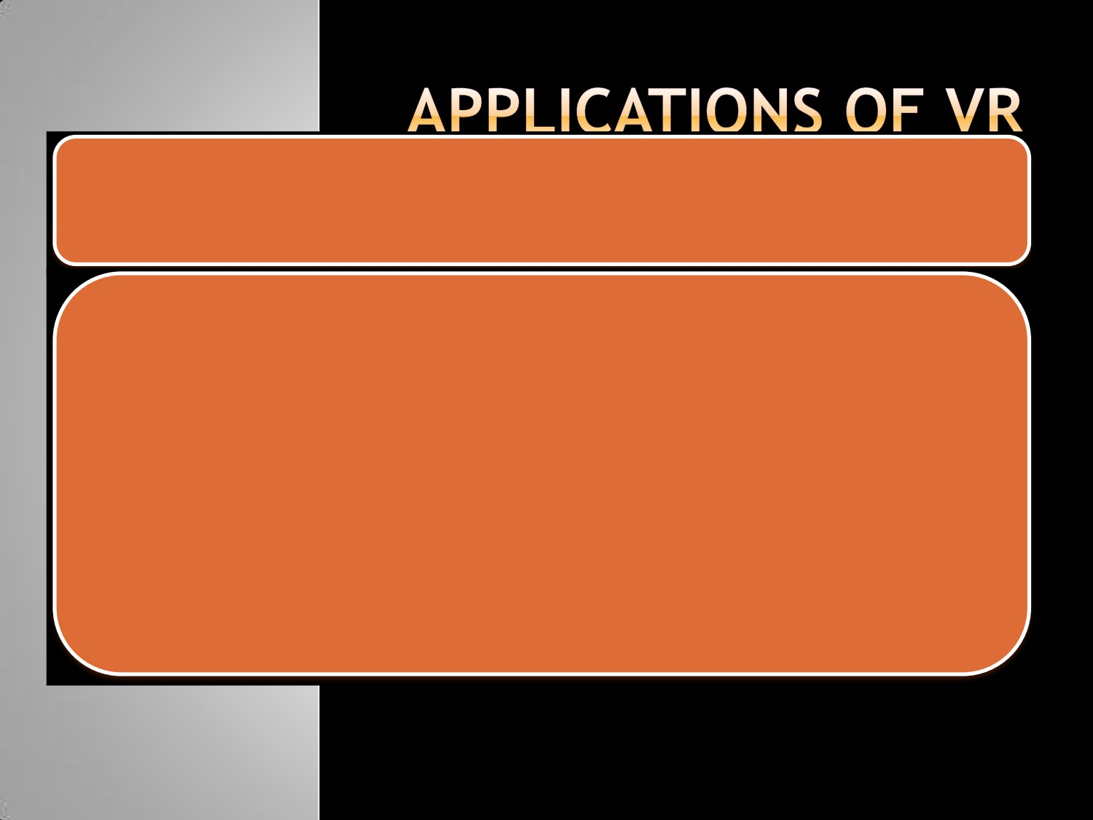

Flight Simulation

- For Pilot training

- Safe and realistic

- Risk free

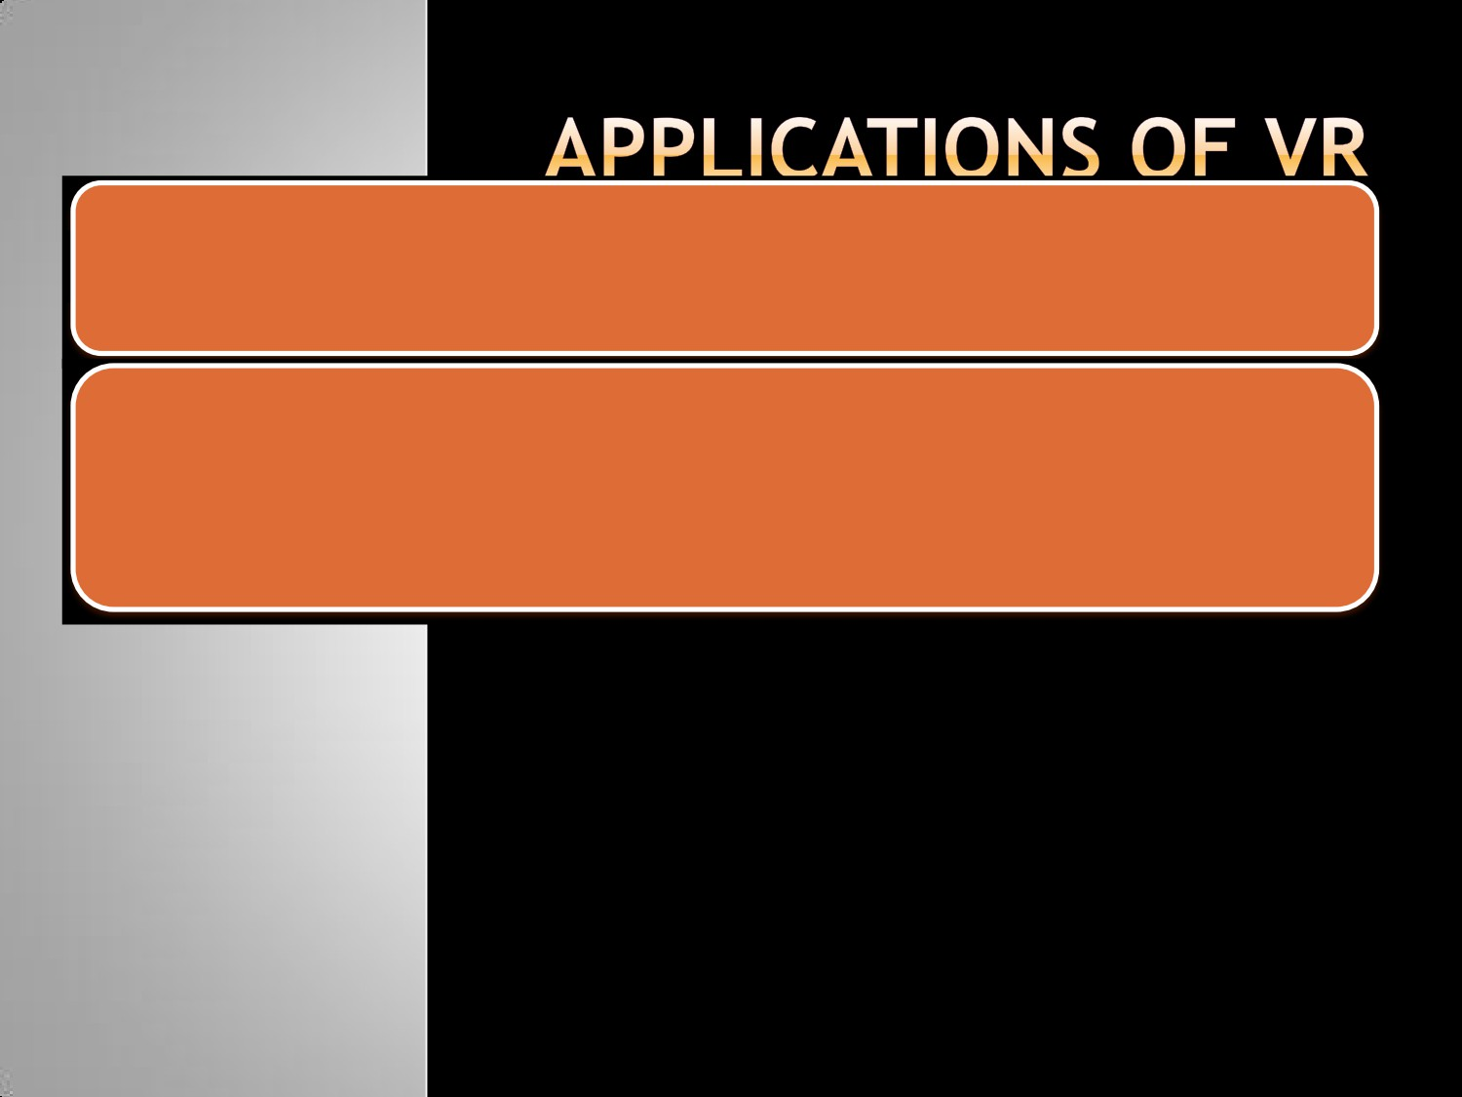

Engineering and design

- CAD and CAM

- View products as it would be seen when manufactured



Human factor modeling

-

Used to model human behavior in the design of new products or

buildings

e.g. simulation of fire in a building and a user can view how the

virtual occupants react to the emergency

-

Helps in designing escape strategies, fire modeling, human

behavior

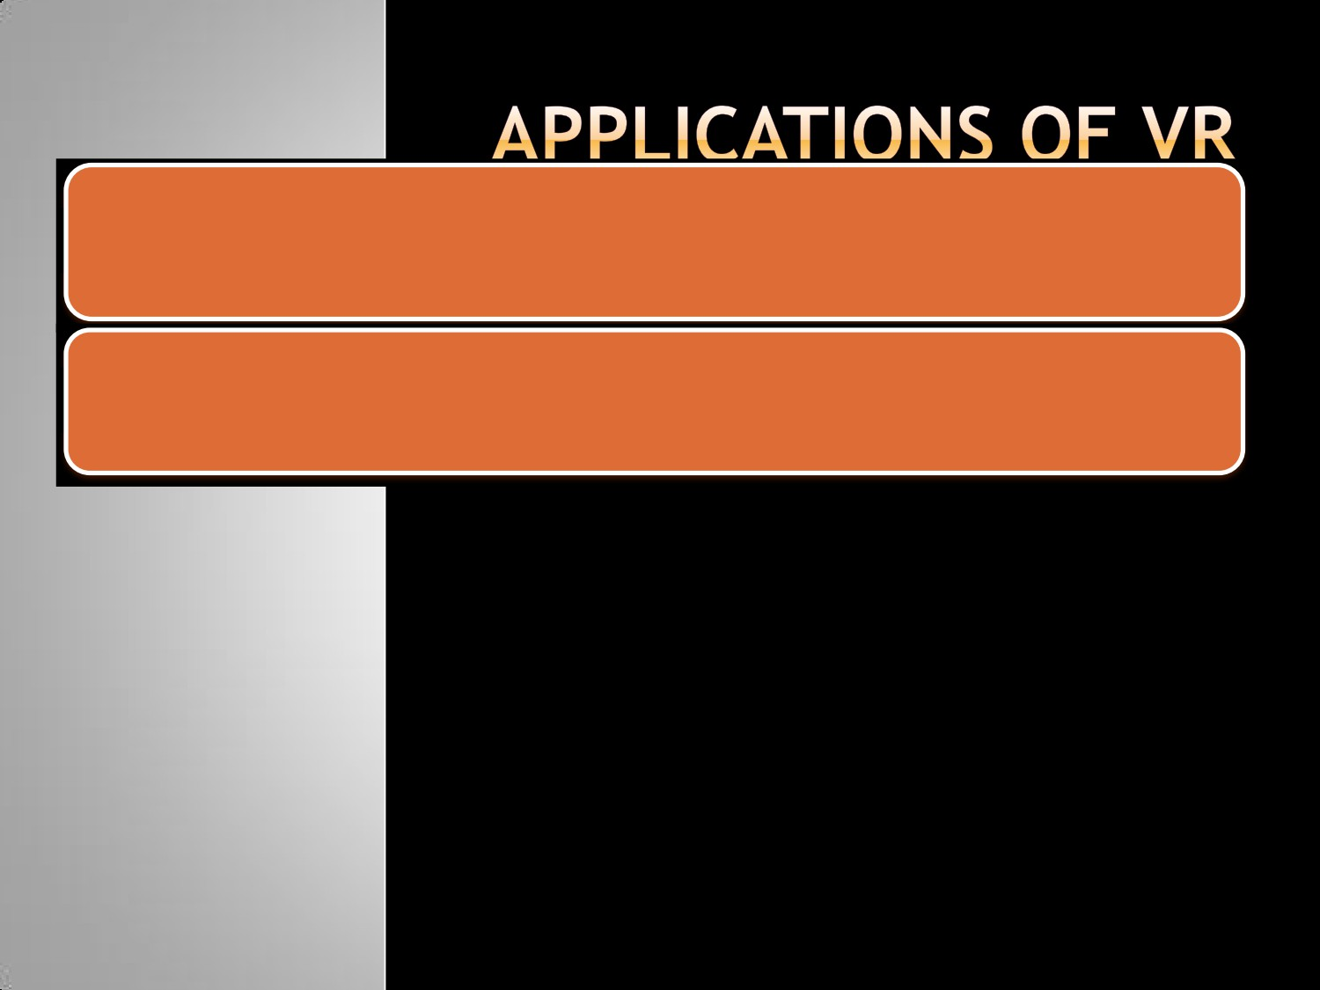

Visualization

- Data visualization